様式第１号その１（第５条第１項の規定による場合）

学 位 授 与 申 請 書

2025年　2月　6日

大阪府立大学長　様

大阪府立大学大学院 　工学研究科　電気・情報系専攻

氏　名　　高山　裕成

大阪府立大学学位規程第５条第１項の規定により

　 修士（工 学）の学位の授与を申請します。

（注意）

1. この申請書は、２通提出すること。

右肩の日付けは西暦年表示。

（Ａ４）

BERT を用いた原文と要約文の分散表現の統合手法

Integration Method for Distributed Representations of

Source and Summary Sentences Using BERT

|  |  |  |  |
| --- | --- | --- | --- |
| 分　野　名  （分野） | 知能情報工学分野 | 氏　名（氏名） | 高山　裕成 |
| Department | Computer Science and Intelligent Systems | Name | Yusei TAKAYAMA |

In recent years, machine learning techniques, particularly deep learning, have achieved high performance in Natural Language Processing (NLP) and Computer Vision (CV). In NLP, Transformer-based models, such as Bidirectional Encoder Representations from Transformers (BERT), have shown remarkable achievements on various tasks, leading to the rise of Large Language Models (LLMs), which are pre-trained on massive text corpora. In this context, to develop high-accuracy models, it is important to choose a method that captures an appropriate distributed representation of sentences and utilizes it efficiently.

Pooling is a fundamental deep learning technique that aggregates and reduces feature dimensionality, enhancing computational efficiency and robustness. In NLP, pooling methods remain less explored than in CV, and their effectiveness is not well understood.

Therefore, Yamato proposed CLS-Average Pooling (CAP), which combines two pooling methods commonly used in BERT, a pooling method using the embedded representations of [CLS] token and an average pooling method of all words in a sentence. Yamato's method has been shown to be effective in text classification tasks when compared individually to using either of these two commonly used methods.

In this study, I propose an extended pooling method based on Yamato’s approach, incorporating the distributed representation of summary texts, which are pre-generated from the original text using an LLM API. The objective of this study is to enable learning that captures a more appropriate distributed representation of sentences and emphasizes contextually important information by utilizing the proposed method.

Figure 1 shows an overview of the entire model of the proposed method. It utilizes two independent pre-trained BERT models to extract four vectors, including the [CLS] token embedding (, ) and the average pooling embedding (, ) for both the input original text and its summary. Within the proposed pooling layer, multiple trainable weight parameters are used to compute the weighted sum of these vectors, producing as the sentence’s distributed representation. Then, I applied different configurations to the proposed pooling layer and conducted text classification experiments under each condition, following Yamato’s research.

As a result of the experiments, the proposed method achieved higher classification accuracy compared to Yamato's method, confirming its effectiveness.

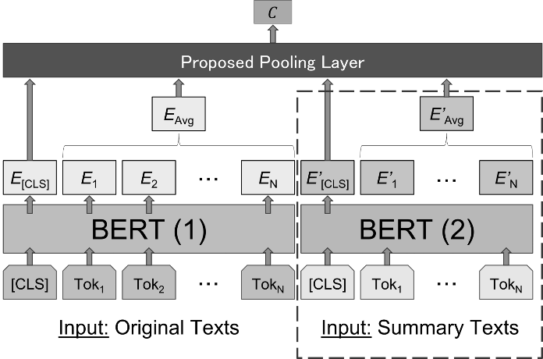

**Figure 1: Overview of The Proposed Model.**